



Essay / Assignment Title: Implementing Machine Learning Models using Python

Programme title:

Name:

Year:

CONTENTS

CONTENTS 2
LIST OF FIGURES 3
INTRODUCTION 5
Learning Outcomes 5
TASK 1: LOAD AND CLEAN THE DATASET 6
Data Cleaning Steps 6
TASK 2: CLASSIFICATION PROBLEM USING DECISION TREES 8
TASK 3: CLUSTERING PROBLEM USING K-MEANS 9
TASK 4: EVALUATING THE CLASSIFICATION ALGORITHM 10
TASK 5: EVALUATING A LINEAR REGRESSION ALGORITHM 11
CONCLUDING REMARKS 12
BIBLIOGRAPHY 13
APPENDIX 14
Python Libraries Used 14
Key Functions and Methods 14
Colab Code Implementation 14

LIST OF FIGURES

Figure 1: Jupyter Notebook Code: Loading and Inspecting Dataset 6
Figure 2: Data Preprocessing: Outlier Detection 7
Figure 3: Machine Learning Model: Decision Tree 8
Figure 4: Jupyter Notebook Code: K-Means Clustering 9
Figure 5: Jupyter Notebook Code: Evaluating Classification Algorithm 10
Figure 6: Jupyter Notebook Code: Linear Regression Model Training and Evaluation 11

Statement of compliance with academic ethics and the avoidance of plagiarism

I honestly declare that this dissertation is entirely my own work and none of its part has been copied from printed or electronic sources, translated from foreign sources and reproduced from essays of other researchers or students. Wherever I have been based on ideas or other people texts I clearly declare it through the good use of references following academic ethics.
(In the case that is proved that part of the essay does not constitute an original work, but a copy of an already published essay or from another source, the student will be expelled permanently from the postgraduate program).

Name and Surname (Capital letters):

.......................................................................................................................................

Date: ........................./........../.........

INTRODUCTION

The main goal of this report is to explain how various types of machine learning models have been developed using Python for handling data, classifying and clustering the data (Sarker, I.H., 2021). The tasks are derived from a dataset named bill_authentication.csv and the report addresses the learning outcomes which focus on the types of data, components of predictive analytics, and an analytical problem using machine learning life cycle.

Learning Outcomes
- LO1: A background check on data types and the usual preprocessing procedures that data scientists employ on data.
- LO2: Understanding of what predictive analytical elements are such as regression, classification and clustering.
- LO3: Prediction in business and analysis: application of a machine learning approach.

TASK 1: LOAD AND CLEAN THE DATASET

The bills authentication dataset that was used in this analysis is very small and was downloaded from Drive. Subsequently, it is cleaned in order to condition the data for analysis.
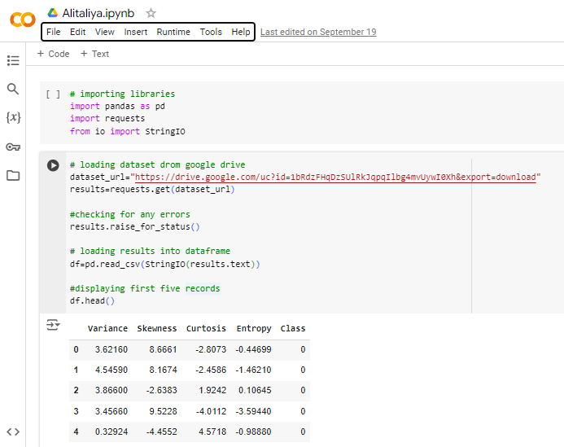
Figure 1: Jupyter Notebook Code: Loading and Inspecting Dataset

Data Cleaning Steps
- Missing Values: Alternatively, in case of any missing values in the dataset, they are deleted.
- Outlier Detection: In this task, Outliers are identified based on IQR method.
- Outlier Treatment: Outliers are treated whereby any number beyond the IQR method and the Z-score method is either rejected or converted.
- Encoding Categorical Variables: While Nominal variables are encoded with One-Hot Encoding and Label Encoding.
- Scaling Numerical Data: For the scaling of numerical features use StandardScaler and MinMaxScaler is used.
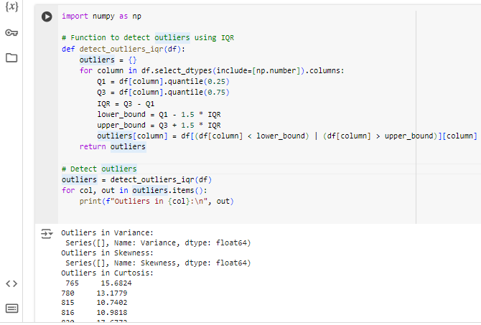
Figure 2: Data Preprocessing: Outlier Detection

TASK 2: CLASSIFICATION PROBLEM USING DECISION TREES

In this research, Decision Tree Classifier is applied to the dataset to create classification models (Charbuty, B. and Abdulazeez, A., 2021). Decision trees are easily understandable models, which make predictions based on certain features values, and which, as well, can capture a non-linearity between features.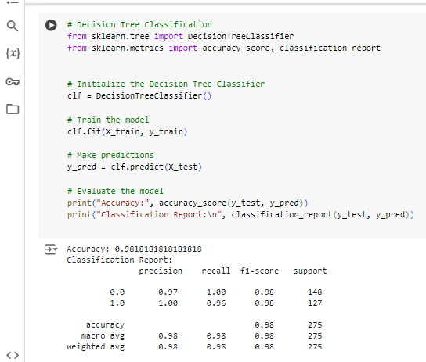
Figure 3: Machine Learning Model: Decision Tree

TASK 3: CLUSTERING PROBLEM USING K-MEANS

The K-Means clustering algorithm is used on the dataset as a method of clustering in its own right without referencing any prior sorting by the analyst or the computer (Ali, I., Rehman, A.U., Khan, D.M., Khan, Z., Shafiq, M. and Choi, J.G., 2022). Here, the data is divided into various clusters depending on similarities in features. This can be particularly beneficial in identifying certain trends that may not easily be identifiable by applying some of the supervised learning approaches.
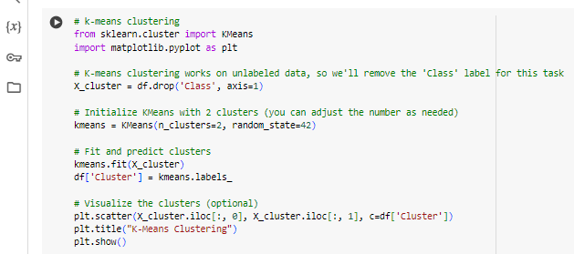
Figure 4: Jupyter Notebook Code: K-Means Clustering

TASK 4: EVALUATING THE CLASSIFICATION ALGORITHM

Evaluation of the classification model is based on the confusion matrix and ROC AUC score is used (Vujović, Ž., 2021). It is crucial to assess one’s models to know their valuable input and output since without such findings it is impossible to fix the model’s mistakes, improving the rate of accuracy.
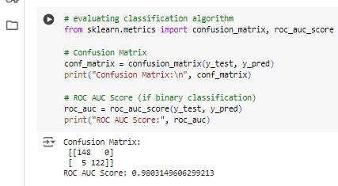
Figure 5: Jupyter Notebook Code: Evaluating Classification Algorithm

TASK 5: EVALUATING A LINEAR REGRESSION ALGORITHM

A Linear Regression model is used for evaluating the regression performance (Maulud, D. and Abdulazeez, A.M., 2020). This model is used for continuously dependent variable predictions with respect to the features and is used for business forecasting and risks analysis.
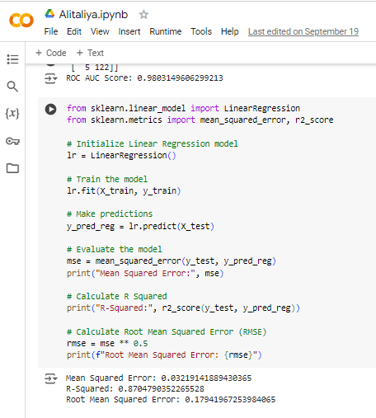
Figure 6: Jupyter Notebook Code: Linear Regression Model Training and Evaluation

CONCLUDING REMARKS

Here, the report outlines the use of different machine learning models in a python coded environment (Thiyagalingam, J., Shankar, M., Fox, G. and Hey, T., 2022). The data loading, data cleaning as well as model evaluation were in the context of understanding the learning outcomes with specific tasks. The report demonstrates knowledge of data management and forecasting to a great extent (Seyedan, M. and Mafakheri, F., 2020).

BIBLIOGRAPHY

Sarker, I.H., 2021. Machine learning: Algorithms, real-world applications and research directions. SN computer science, 2(3), p.160.
Charbuty, B. and Abdulazeez, A., 2021. Classification based on decision tree algorithm for machine learning. Journal of Applied Science and Technology Trends, 2(01), pp.20-28.
Ali, I., Rehman, A.U., Khan, D.M., Khan, Z., Shafiq, M. and Choi, J.G., 2022. Model selection using K-means clustering algorithm for the symmetrical segmentation of remote sensing datasets. Symmetry, 14(6), p.1149.
Vujović, Ž., 2021. Classification model evaluation metrics. International Journal of Advanced Computer Science and Applications, 12(6), pp.599-606.
Maulud, D. and Abdulazeez, A.M., 2020. A review on linear regression comprehensive in machine learning. Journal of Applied Science and Technology Trends, 1(2), pp.140-147.
Thiyagalingam, J., Shankar, M., Fox, G. and Hey, T., 2022. Scientific machine learning benchmarks. Nature Reviews Physics, 4(6), pp.413-420.
Seyedan, M. and Mafakheri, F., 2020. Predictive big data analytics for supply chain demand forecasting: methods, applications, and research opportunities. Journal of Big Data, 7(1), p.53.

APPENDIX

Python Libraries Used
- Pandas
- Requests
- Numpy
- Scikit-learn
- Matplotlib

Key Functions and Methods
- train_test_split(): Divides the database into the training data and the test data since the main scope of this phase is to evaluate the model.
- DecisionTreeClassifier(): Used to initialize a decision tree classifier for classification based on problems.
- KMeans(): Uses a clustering algorithm, namely K-means for data clustering with a view of categorizing data into separate clusters.
- Mean_squared_error(): Estimates the variance of the prediction residuals, which in return measures the goodness of fit of the regression models.

Colab Code Implementation
All the code used to perform data loading/visualization, data cleaning/preprocessing and both classification/regression can be seen in the Google Colab notebook linked below.
View the Colab Notebook

